1. Login to MySQL and view all databases already present. You should get

following result :

show databases;

+--------------------+

| Database |

+--------------------+

| assignment1 |

| information_schema |

| may2025batch |

| mydatabase |

| mysql |

| performance_schema |

| sakila |

| sys |

| world |

+--------------------+

9 rows in set (0.01 sec)

2. Write an SQL statement to create a simple table countries including columns

country_id,country_name and region_id. After this display the structure of

table as below :

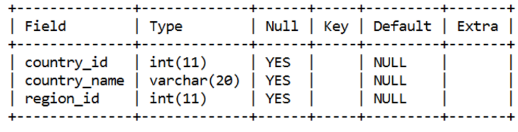

mysql> create table countryy(country_id int(11), country_name varchar(20), region_id int(11));

Query OK, 0 rows affected, 2 warnings (0.14 sec)

mysql> show tables;

+-----------------------+

| Tables_in_assignment1 |

+-----------------------+

| country |

| countryy |

| jobs |

+-----------------------+

3 rows in set (0.02 sec)

mysql> desc countryy;

+--------------+-------------+------+-----+---------+-------+

| Field | Type | Null | Key | Default | Extra |

+--------------+-------------+------+-----+---------+-------+

| country_id | int | YES | | NULL | |

| country_name | varchar(20) | YES | | NULL | |

| region_id | int | YES | | NULL | |

+--------------+-------------+------+-----+---------+-------+

3 rows in set (0.02 sec)

3. Write an SQL statement to create a table named jobs including columns

job_id, job_title, min_salary, max_salary and check whether the

max_salary amount exceeding the upper limit 25000. Also set job_id as

primary key and entering null values for job_title is not allowed.

create table job

-> (job_id int primary key,

-> job_title varchar(20) not null,

-> min_salary decimal(7,2),

-> max_salary decimal(7,2));

Query OK, 0 rows affected (0.07 sec)

mysql> desc job;

+------------+--------------+------+-----+---------+-------+

| Field | Type | Null | Key | Default | Extra |

+------------+--------------+------+-----+---------+-------+

| job_id | int | NO | PRI | NULL | |

| job_title | varchar(20) | NO | | NULL | |

| min_salary | decimal(7,2) | YES | | NULL | |

| max_salary | decimal(7,2) | YES | | NULL | |

+------------+--------------+------+-----+---------+-------+

4 rows in set (0.02 sec)

mysql> alter table job

-> add constraint check(max_salary>25000);

Query OK, 0 rows affected (0.11 sec)

Records: 0 Duplicates: 0 Warnings: 0

mysql> desc job;

+------------+--------------+------+-----+---------+-------+

| Field | Type | Null | Key | Default | Extra |

+------------+--------------+------+-----+---------+-------+

| job_id | int | NO | PRI | NULL | |

| job_title | varchar(20) | NO | | NULL | |

| min_salary | decimal(7,2) | YES | | NULL | |

| max_salary | decimal(7,2) | YES | | NULL | |

+------------+--------------+------+-----+---------+-------+

4 rows in set (0.02 sec)

4. Write a SQL statement to create a table named job_histry including columns

employee_id, start_date, end_date, job_id and department_id

mysql> create table jon_histry

-> (employee_id int,

-> start_date date,

-> end_date date,

-> job_id int,

-> department_id int);

Query OK, 0 rows affected (0.03 sec)

mysql> desc jon_histry;

+---------------+------+------+-----+---------+-------+

| Field | Type | Null | Key | Default | Extra |

+---------------+------+------+-----+---------+-------+

| employee_id | int | YES | | NULL | |

| start_date | date | YES | | NULL | |

| end_date | date | YES | | NULL | |

| job_id | int | YES | | NULL | |

| department_id | int | YES | | NULL | |

+---------------+------+------+-----+---------+-------+

5 rows in set (0.00 sec)

5. Write an SQL statement to alter a table named countries to make sure that no

duplicate data against column country_id will be allowed at the time of

insertion.

mysql> alter table countryy

-> add constraint unique(country_id);

Query OK, 0 rows affected (0.04 sec)

Records: 0 Duplicates: 0 Warnings: 0

6. Write an SQL statement to create a table named jobs including columns job_id,

job_title, min_salary and max_salary, and make sure that, the default value

for job_title is blank and min_salary is 8000 and max_salary is NULL will be

entered automatically at the time of insertion if no value assigned for the

specified columns.

create table jobss

-> (job_id int ,

-> job_title varchar(20) default ' ',

-> min_salary decimal(7,2) default 8000,

-> max_salary decimal(7,2) default NULL);

Query OK, 0 rows affected (0.06 sec)

mysql> desc jobss;

+------------+--------------+------+-----+---------+-------+

| Field | Type | Null | Key | Default | Extra |

+------------+--------------+------+-----+---------+-------+

| job_id | int | YES | | NULL | |

| job_title | varchar(20) | YES | | | |

| min_salary | decimal(7,2) | YES | | 8000.00 | |

| max_salary | decimal(7,2) | YES | | NULL | |

+------------+--------------+------+-----+---------+-------+

4 rows in set (0.00 sec)

7. Create a Department table with following structure

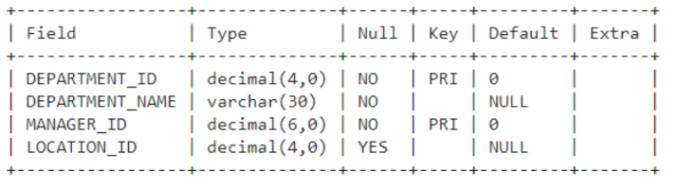

CREATE TABLE department

-> (department_id DECIMAL(4,0) NOT NULL DEFAULT 0,

-> department_name varchar(30) NOT NULL DEFAULT '',

-> manager_id decimal(6,0) NOT NULL DEFAULT 0,

-> location_id decimal(4,0) DEFAULT NULL,

-> primary key(department_id, manager_id));

Query OK, 0 rows affected (0.05 sec)

mysql> desc department;

+-----------------+--------------+------+-----+---------+-------+

| Field | Type | Null | Key | Default | Extra |

+-----------------+--------------+------+-----+---------+-------+

| department_id | decimal(4,0) | NO | PRI | 0 | |

| department_name | varchar(30) | NO | | | |

| manager_id | decimal(6,0) | NO | PRI | 0 | |

| location_id | decimal(4,0) | YES | | NULL | |

+-----------------+--------------+------+-----+---------+-------+

4 rows in set (0.00 sec)

8. Write an SQL statement to create a table employees including columns

employee_id, first_name, last_name, email, phone_number hire_date, job_id,

salary, commission, manager_id and department_id and make sure that, the

employee_id column does not contain any duplicate value at the time of

insertion and the foreign key columns combined by department_id and

manager_id columns contain only those unique combination values, which

combinations are exists in the departments table.

create table departments

-> ( department_id DECIMAL(4,0) NOT NULL,

-> department_name VARCHAR(30) NOT NULL,

-> manager_id DECIMAL(6,0) NOT NULL,

-> location_id DECIMAL(4,0),

-> PRIMARY KEY (department_id, manager_id) -- composite primary key

-> );

Query OK, 0 rows affected (0.05 sec)

mysql> desc departments;

+-----------------+--------------+------+-----+---------+-------+

| Field | Type | Null | Key | Default | Extra |

+-----------------+--------------+------+-----+---------+-------+

| department_id | decimal(4,0) | NO | PRI | NULL | |

| department_name | varchar(30) | NO | | NULL | |

| manager_id | decimal(6,0) | NO | PRI | NULL | |

| location_id | decimal(4,0) | YES | | NULL | |

+-----------------+--------------+------+-----+---------+-------+

4 rows in set (0.02 sec)

mysql> CREATE TABLE employees (

-> employee_id INT UNIQUE,

-> first_name VARCHAR(20),

-> last_name VARCHAR(20),

-> email VARCHAR(20),

-> phone_number VARCHAR(20),

-> hire_date DATE,

-> job_id INT,

-> salary DECIMAL(7,2),

-> commission DECIMAL(7,2),

-> manager_id DECIMAL(6,0),

-> department_id DECIMAL(4,0),

->

-> FOREIGN KEY (department_id, manager_id)

-> REFERENCES department(department_id, manager_id)

-> );

Query OK, 0 rows affected (0.08 sec)